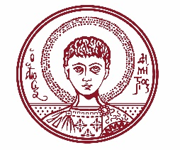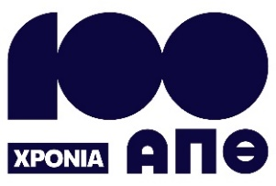

ARISTOTLE UNIVERSITY OF THESSALONIKI
PRESS OFFICE

ph. (+30)2310 997158 e-mail:press@auth.gr
Administration Building «Κ. Karatheodori» AUTH, P.C. 541 24, Thessaloniki
^{@Aristoteleio @authuniversity} ^{@Auth_University}

PRESS RELEASE

The School of Film of AUTH maps and presents the cinemas of Thessaloniki from 1945 to 2000
Thessaloniki, 1/9/2025

The website thessalonikicinemas.gr is now publicly available, presenting not only the cinemas of Thessaloniki but also a topography of cinema in the city from 1945 to 2000.

The website is part of a research project by the Laboratory for the Study of Greek Cinema and Television (EMEKT) at the School of Film of Aristotle University of Thessaloniki (AUTH), focusing on mapping cinema venues in the Thessaloniki urban area during the period 1945–2000.

Through documented archival material, maps, and historical references, the project highlights the presence of cinema in the daily life of the city.

The website functions as a digital archive and dynamic database, providing access to information about screening venues (exact location, opening and closing dates, seasonality, first- or second-run screenings) and photographic material (both archival and depicting current conditions and uses).

An interactive map displays active cinemas by decade, showcasing the changes in Thessaloniki's urban character over time.

The project began about a year ago and encourages public participation, either by submitting information and personal memories or by engaging with the interactive map.
In addition, the effort will be supported by interviews with former cinema owners, their descendants, and members of the public who were active moviegoers during the city's cinematic past.

The research team is supervised and guided by Professor Eleftheria Thanouli, Director of EMEKT and faculty member at the School of Film of AUTH. The project is based on an idea by Dr. Paraskevas Mouratidis, member of the Laboratory Teaching Staff (EDIP) of the Department and EMEKT, regarding the history of the city’s cinema halls.

The project is carried out with the support of the AUTH Research Committee and could not have been completed without the contribution of undergraduate students from the School of Film who participated in EMEKT's activities, specifically: Evangelia Statheropoulou (coordinator), Anastasia Chasakiöili, Dimitris Vafeiadis, Ioannis Bais (student at the Department of Informatics), Thanasis Laganis, Angelos Grantounis, Eleni Baklavara, Eleftheria Gina Nedelkov, and Anna Petrakopoulou.

___________________________________________________
We kindly request that this event be published, broadcast, and covered by the media

