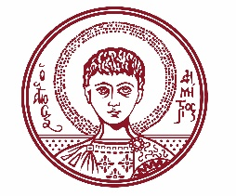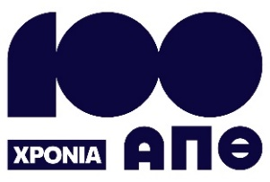

ARISTOTLE UNIVERSITY OF THESSALONIKI
PRESS OFFICE

ph. (+30)2310 997158 e-mail:press@auth.gr
Administration Building «Κ. Karatheodori» AUTH, P.C. 541 24, Thessaloniki
^{@Aristoteleio @authuniversity} ^{@Auth_University}

PRESS RELEASE

International Conference at Aristotle University on the Interaction Between Ancient Greek and Latin

Thessaloniki, September 29, 2025

The School of Philology at Aristotle University will host an international conference titled "Trends in Classics – Greek and Latin Linguistics 2: Aspects of Greco-Latin Language Contact" on Friday, October 3, and Saturday, October 4, 2025, at the KEDEA Conference Center.

According to the organizers, the conference aims to explore the interaction between the ancient Greek and Latin languages across various literary genres and textual sources. Special emphasis will be placed on the linguistic traces left by the movement of people from the Greek East to the Latin West up to the 6th century, as well as on the parallel evolution of the two languages after classical antiquity.

Thirty distinguished scholars from Greece and abroad will participate in the conference. This is the second event in the "Trends in Classics – Greek and Latin Linguistics" series, a new initiative launched by the School of Philology at Aristotle University. The series aspires to become a point of reference within the academic community.

More information, including the full conference program, is available at the following link: https://lit.auth.gr/research/conferences/tcgll-conference/tcgll_02/

The conference proceedings will also be available for online attendance via the following link: https://audiovisual.auth.gr/video/106951

___________________________________________________
We kindly request that this event be published, broadcast, and covered by the media.

