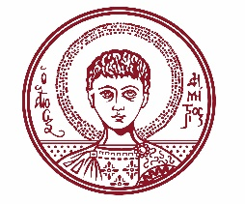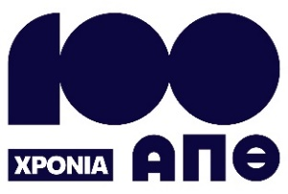

ARISTOTLE UNIVERSITY OF THESSALONIKI
PRESS OFFICE

ph. (+30)2310 997158 e-mail:press@auth.gr
Administration Building «Κ. Karatheodori» AUTH, P.C. 541 24, Thessaloniki
^{@Aristoteleio @authuniversity} 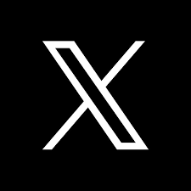^{@Auth_University}

PRESS RELEASE

New Public Science Lecture Series at the School of Physics of the Aristotle University

Thessaloniki, 2/10/2025

The School of Physics of the Aristotle University of Thessaloniki presents its new public science lecture program for the academic year 2025–2026. The lectures will take place in Lecture Hall A31 of the School of Physics and will also be streamed online.

According to the organizers, the goal of the lectures is to bring the science of Physics and modern research closer to society.

Throughout the lecture series, distinguished professors and researchers from the School will present cutting-edge topics — in language accessible to all — covering cosmology, climate change, nanotechnology, particle physics, artificial intelligence, and the creation of matter.

The first lecture, titled "The Foundations of the Modern Cosmological Model", will be delivered by Professor Emmanouil Plionis of the School of Physics of the Aristotle University, former Director and Chair of the Board of the National Observatory of Athens. It will take place on Tuesday, October 7, 2025, from 19:15 to 20:15.

Lecture Program – Winter Semester 2025

Tuesday, October 7 | 19:15–20:15
"The Foundations of the Modern Cosmological Model"
Speaker: Emmanouil Plionis, School of Physics, Aristotle University; National Observatory of Athens

Thursday, November 6 | 18:15–19:15
"Global Warming, the Greenhouse Effect, and Climate Change"
Speaker: Kleareti Tourpali, School of Physics, Aristotle University

Thursday, December 11 | 18:15–19:15
"Nanotechnology and Its Applications in Energy, Health, Agri-food, and Electronics"
Speaker: Argyris Laskarakis, School of Physics, Aristotle University

Lecture Program – Spring Semester 2026

Thursday, February 19 | 18:15–19:15
"Nanotechnology Industry in Greece: Current Achievements and Future Prospects"
Speaker: Stergios Logothetidis, School of Physics, Aristotle University

Thursday, March 12 | 18:15–19:15
"The Large Hadron Collider at CERN, the Higgs Boson, and the Future of Particle Physics"
Speaker: Konstantinos Kordas, School of Physics, Aristotle University

Thursday, April 23 | 18:15–19:15
"How Does Artificial Intelligence Learn Physics? An Introduction to Physics-Informed Neural Networks"
Speaker: Christos Volos, School of Physics, Aristotle University

Thursday, May 14 | 18:15–19:15
"Creation: Universe, Nuclei, Atoms, Matter. How Do We Exist?"
Speaker: Christos Eleftheriadis, School of Physics, Aristotle University

Participation in the School of Physics’ lecture series is open to the public.

More information: https://www.physics.auth.gr/event_announcements/6635
___________________________________________________
We kindly request that this event be published, broadcast, and covered by the media.

