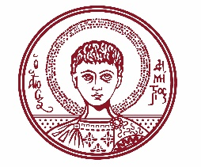

ARISTOTLE UNIVERSITY OF THESSALONIKI
PRESS OFFICE

ph. (+30)2310 997158 e-mail:press@auth.gr
Administration Building «Κ. Karatheodori» AUTH, P.C. 541 24, Thessaloniki
^{@Aristoteleio @authuniversity} ^{@Auth_University}

PRESS RELEASE

Talk by Elder Ephraim of Vatopaidi at the School of Theology of the Aristotle University

Thessaloniki, 6/10/2025

A talk entitled "Experiencing Christ" will be delivered by the Very Reverend Archimandrite Elder Ephraim, Abbot of the Holy and Great Monastery of Vatopaidi, during an honorary event organized by the Deanery of the Faculty of Theology at the Aristotle University. The event will take place on Thursday, October 9, 2025, at 12:00, in Lecture Hall D of the School of Theology.

The event poster is attached.
___________________________________________________
We kindly request that this event be published, broadcast, and covered by the media.

