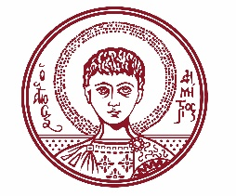

ARISTOTLE UNIVERSITY OF THESSALONIKI
PRESS OFFICE

ph. (+30)2310 997158 e-mail:press@auth.gr
Administration Building «Κ. Karatheodori» AUTH, P.C. 541 24, Thessaloniki
^{@Aristoteleio @authuniversity} ^{@Auth_University}

PRESS RELEASE

Opening of the Map Exhibition “University City: 100 Years of AUTH”

Thessaloniki, 8/10/2025

The Aristotle University is holding a Map Exhibition titled: “University City: 100 Years of AUTH The development of the Aristotle University campus through maps and topographic diagrams”, from October 15 to December 31, 2025, at the Aristotle Museum of Natural History (Pier A, Thessaloniki Port).

The opening of the Exhibition will take place on Wednesday, October 15, 2025, at 18:00.

The Exhibition is organized as part of the celebrations for the 100th anniversary of the founding and operation of the Aristotle University. It presents and outlines the history of the creation and development of the University campus, based both on visual representations in maps and topographic diagrams, as well as on descriptions found in historical texts and documents.

Admission to the Exhibition is free to the public.
___________________________________________________
We kindly request that this event be published, broadcast, and covered by the media.

