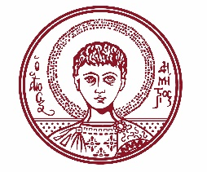

ARISTOTLE UNIVERSITY OF THESSALONIKI
PRESS OFFICE

ph. (+30)2310 997158 e-mail:press@auth.gr
Administration Building «Κ. Karatheodori» AUTH, P.C. 541 24, Thessaloniki
^{@Aristoteleio @authuniversity} ^{@Auth_University}

PRESS RELEASE

Commemorative Event for Manolis Andronikos at the Aristotle University

Thessaloniki, 9/10/2025

The Aristotle University Alumni Association is organizing a commemorative event in honor of Manolis Andronikos on Friday, October 17, 2025, at 19:00, in the Ceremony Hall.

The event is held as part of the celebrations marking the 100th anniversary of the founding and operation of the Aristotle University.

The event will be addressed by the Rector of the Aristotle University, Professor Kyriakos Anastasiadis; the Vice Rector for International Relations, Outreach, Lifelong Learning and Student Welfare, Professor Iakovos Michailidis; the Dean of the School of Philosophy, Professor Konstantinos Tsioumis; the Chair of the School of History and Archaeology, Professor Athanasios Semoglou; and the President of the Aristotle University Alumni Association, Honorary Professor Zacharias Skouras.

Admission to the event is open to the public.

The event poster and program are attached.
_____________________________________________
We kindly request that this event be published, broadcast, and covered by the media.

