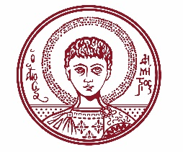

ARISTOTLE UNIVERSITY OF THESSALONIKI
PRESS OFFICE

ph. (+30)2310 997158 e-mail:press@auth.gr
Administration Building «Κ. Karatheodori» AUTH, P.C. 541 24, Thessaloniki
^{@Aristoteleio @authuniversity} ^{@Auth_University}

PRESS RELEASE

Distinguished Alumni of Aristotle University Discuss Its Research Work and Future

Thessaloniki, 10 October 2025

Six distinguished alumni of Aristotle University, active in both the Greek and international academic communities, will evaluate the university’s current scientific work and offer proposals for its future. This will take place during a roundtable discussion organized by the Aristotle University Alumni Association and the University’s Rectorate.

The event will be held on Thursday, October 16, 2025, at 6:30 PM, in the "Alexandros Papanastasiou" Ceremony Hall of the Old Building of the School of Philosophy.

The panel will include (in alphabetical order): Kostas Arkolakis, Michail Gatzoulis, Dimitris Ch. Lagoudas, Vasilis Ntziachristos, Theodoros Papangelis, and Nektarios Tavernarakis. The discussion will be moderated by Zacharias Skouras, President of the Alumni Association and Honorary Professor of Biology.

The event is part of the celebrations marking the 100th anniversary of the founding and operation of Aristotle University.

Short CVs of the speakers as well as the event poster are attached.
___________________________________________________
We kindly request that this event be published, broadcast, and covered by the media.

