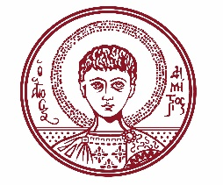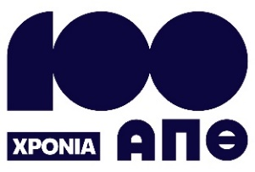

ARISTOTLE UNIVERSITY OF THESSALONIKI
PRESS OFFICE

ph. (+30)2310 997158 e-mail:press@auth.gr
Administration Building «Κ. Karatheodori» AUTH, P.C. 541 24, Thessaloniki
^{@Aristoteleio @authuniversity} ^{@Auth_University}

PRESS RELEASE

International Symposium on Sustainable Water Management at Aristotle University

Thessaloniki, 15 October 2025

The UNESCO C2C Center for Integrated and Interdisciplinary Water Resources Management of the Aristotle University is organizing an International Symposium titled: "Water and Sustainability: 50 Years of the Intergovernmental Hydrological Programme (IHP) of UNESCO". The event will take place on Thursday, 16 October 2025, at 10:00, at the KEDEA Building.

According to the organizers, the increasing pressure on water resources—driven by an unsustainable development model characterized by overexploitation of water, negative water balances in hydrological basins, severe pollution, unequal water distribution, and the effects of climate change—represents one of the most significant global challenges. They note that, although Greece is rich in water resources in certain areas, it still faces many of these challenges.

In this context, the organizers highlight the crucial role played by UNESCO’s Intergovernmental Hydrological Programme (IHP), which promotes scientific research, knowledge exchange, and the strengthening of international cooperation. The Symposium aims to support this mission by providing a meaningful platform for dialogue and collaboration on sustainable water management.

According to the Symposium’s program, international experts in water management will deliver presentations, alongside representatives from UNESCO Water Centres and UNESCO Chairs. A special session will be dedicated to the work of the Greek UNESCO Chairs involved in water-related topics. Departments from Aristotle University will also present recent research findings related to water.

During the Symposium, the UNESCO Center for Integrated and Interdisciplinary Water Resources Management and CrediaBank will sign a Memorandum of Understanding, marking the beginning of collaboration in educational and research initiatives. This agreement aims to develop joint actions with various departments of Aristotle University and to promote best practices for integrated and sustainable water resource and project management. The organizers state that the ultimate goal of these initiatives is environmental well-being and the advancement of international cooperation.

They also emphasize that the Symposium offers a significant opportunity to showcase research and educational activities connected to the Intergovernmental Hydrological Programme, while also fostering knowledge and experience exchange between Greek and international scientists. These activities span a wide range of topics—from modern hydrological methods and water resource management to climate change adaptation.

Throughout the Symposium, a video titled “Water Through the Eyes of the New Generation”, created by students of Aristotle University, will be screened.

The full Symposium program is available at the following link:
https://www.keody.auth.gr/wp-content/uploads/2025/10/Programme.pdf
___________________________________________________
We kindly request that this event be published, broadcast, and covered by the media.

