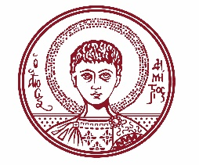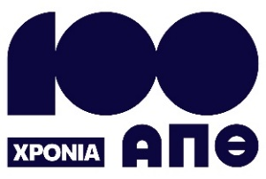

ARISTOTLE UNIVERSITY OF THESSALONIKI
PRESS OFFICE

ph. (+30)2310 997158 e-mail:press@auth.gr
Administration Building «Κ. Karatheodori» AUTH, P.C. 541 24, Thessaloniki
^{@Aristoteleio @authuniversity} ^{@Auth_University}

PRESS RELEASE

Memorandum of Cooperation between Aristotle University and the Academy of Athens

Thessaloniki, October 23, 2025

Aristotle University and the Academy of Athens signed a Memorandum of Cooperation yesterday, Wednesday, October 22, 2025, at the Academy’s headquarters. The Rector of Aristotle University, Professor Kyriakos Anastasiadis, the President of the Academy of Athens, Honorary Professor Michail Tiverios, and the Secretary General, Honorary Professor Christos Zerefos, co-signed the memorandum.

After the signing ceremony, the Rector of Aristotle University, Professor Kyriakos Anastasiadis, stated: “The proposal to establish an agreement between our University and the highest intellectual institution of our country is a great honor, an expression of trust, and a tangible recognition of Aristotle University’s quality. I consider this agreement a starting point for joint initiatives of mutual interest, with expected positive outcomes.”

The President of the Academy of Athens expressed his great joy and satisfaction for the signing of this agreement, which will mark the beginning of a creative and meaningful partnership.

The event was attended by the Vice-Rector for Research and Innovation, Professor Ioannis Rekanos; the Vice-Rector for International Relations, Outreach, Lifelong Learning, and Student Welfare, Professor Iakovos Michailidis; the Dean of the School of Law and Rector’s Advisor, Professor Panagiotis Glavinis; and the Legal Counsel of the Academy, Mr. Georgios Iatrou.

Photographs are attached.
___________________________________________________
We kindly request that this event be published, broadcast, and covered by the media.

