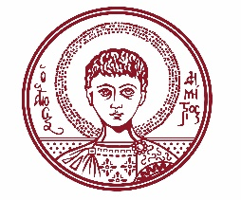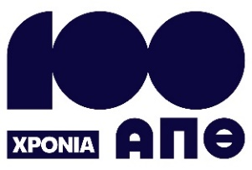

ARISTOTLE UNIVERSITY OF THESSALONIKI
PRESS OFFICE

ph. (+30)2310 997158 e-mail:press@auth.gr
Administration Building «Κ. Karatheodori» AUTH, P.C. 541 24, Thessaloniki
^{@Aristoteleio @authuniversity} ^{@Auth_University}

PRESS RELEASE

Informative Event on Nutrition and Health at Aristotle University

Thessaloniki, November 3, 2025

The Health Committee of the Aristotle University is organizing an event titled “Superfoods & the Campus” on Monday, November 10, 2025, from 18:30 to 21:00, at KEDEA.

Distinguished scientists will engage in discussion with the audience and answer questions about dietary supplements and functional foods. The speakers will explain the differences between legal and prohibited supplements, outlining their possible effects on health. They will also provide guidance on how to read nutrition labels correctly, helping participants make healthier and safer dietary choices.

During the event, there will be simultaneous interpretation in sign language.

Admission is free to the public.

The event poster is attached.
___________________________________________________
We kindly request that this event be published, broadcast, and covered by the media.

