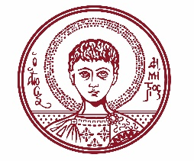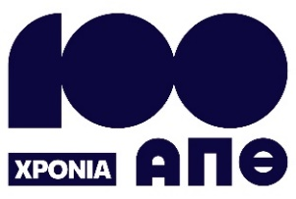

ARISTOTLE UNIVERSITY OF THESSALONIKI
PRESS OFFICE

ph. (+30)2310 997158 e-mail:press@auth.gr
Administration Building «Κ. Karatheodori» AUTH, P.C. 541 24, Thessaloniki
^{@Aristoteleio @authuniversity} ^{@Auth_University}

PRESS RELEASE

Event at Aristotle University: “Studies – Skills & the Job Market: Building Bridges with the Business World”
Thessaloniki, 10/11/2025
The Career Services Office of the Aristotle University and Thessaloniki Chamber of Commerce and Industry (TCCI) co-organize an event entitled “Studies – Skills & the Job Market: Building Bridges with the Business World”, on Thursday, November 20, 2025, from 10:00 to 14:30, at KEDEA (Research Dissemination Center).
According to the organizers, the event represents a dynamic initiative that connects the University with the labor market, bringing together businesses, students, and graduates in a meaningful dialogue about skills, needs, and emerging opportunities. The event creates a meeting point where companies can get to know talented young people and the ideas of the academic community, while students and graduates gain direct insight into the market and their professional prospects.
As part of the event, a Networking Area with Businesses – Info Desks will operate (from 12:15 to 14:15), where participants will have the opportunity to attend meetings, submit CVs, and take part in short interviews.
Further information and the detailed event program are available at the following link: https://career.auth.gr/events/imerida-stadiodromias-spoudes-dexiotites-agora-ergasias-gefyres-me-ton-epicheirimatiko-kosmo-pebti-20-noemvriou-kedea-apth/
___________________________________________________
We kindly request that this event be published, broadcast, and covered by the media.

