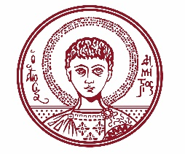

ARISTOTLE UNIVERSITY OF THESSALONIKI
PRESS OFFICE

ph. (+30)2310 997158 e-mail:press@auth.gr
Administration Building «Κ. Karatheodori» AUTH, P.C. 541 24, Thessaloniki
^{@Aristoteleio @authuniversity} ^{@Auth_University}

PRESS RELEASE

Conference and Opening of the Exhibition “The Future as a Project: Doxiadis in Skopje” at the School of Architecture, Aristotle University

Thessaloniki, 10/11/2025

The School of Architecture of the Aristotle University organizes an Exhibition and Conference entitled “The Future as a Project: Doxiadis in Skopje” on Tuesday, November 11, 2025, at the School of Engineering.

Following its presentations at the Benaki Museum in Athens (2018–2019) and at the Museum of Contemporary Art in Skopje (2023–2024), the Exhibition is now being transferred to Thessaloniki, specifically to the Aristotle University. At the center of the Exhibition lies the work of Constantinos A. Doxiadis and his role in the reconstruction of the city of Skopje after the devastating earthquake of 1963.

At 16:00, in class 301 of the School of Architecture, the Conference will take place, featuring Assistant Professor Kalliopi Amygdalu from the School of Architecture of the National Technical University of Athens, Professor Ana Ivanovska Deskova from the Faculty of Architecture of the Ss. Cyril and Methodius University in Skopje, and Associate Professor Nikos Patsavos from the School of Architecture of the University of Ioannina.

At 19:00, in the Exhibition Hall of the School of Architecture, the Opening of the Exhibition will take place. The Exhibition will remain open until December 23, 2025.

The event poster is attached.

___________________________________________________
We kindly request that this event be published, broadcast, and covered by the media.

