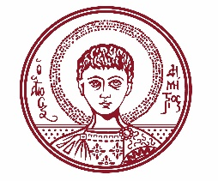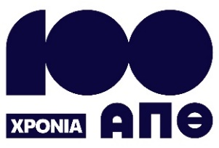

ARISTOTLE UNIVERSITY OF THESSALONIKI
PRESS OFFICE

ph. (+30)2310 997158 e-mail:press@auth.gr
Administration Building «Κ. Karatheodori» AUTH, P.C. 541 24, Thessaloniki
^{@Aristoteleio @authuniversity} ^{@Auth_University}

PRESS RELEASE

Researchers’ Night 2025: AUTH Brings Physics and Astronomy Closer to the Public

Thessaloniki, 22/9/2025

Aristotle University of Thessaloniki (AUTH) is coordinating the European Researchers’ Night, which will take place on Friday, September 26, 2025, from 17:00 to 23:00, at the NOESIS Science Center and Technology Museum, as part of the EU’s HORIZON program titled "PICO – Physics for All."

The event will be held simultaneously in Greece, Italy, France, and Spain, with the participation of leading scientific institutions, aiming to inform the public about topics in Physics and Astronomy.

Visitors will have the opportunity to enjoy a rich program of activities aimed at all age groups, focusing on the applications of physics in everyday life and the latest discoveries in astronomy.

According to the organizers, the evening will include exciting interactive experiments and simulations, demonstrations of scientific constructions, creative activities for children, a book and gift raffle, and a spectacular "astro-party" featuring the observation of the planet Saturn using telescopes.

These activities will be carried out by research teams and laboratories from the Department of Physics at AUTH. These include the Gravitational Waves Laboratory, Relativistic Astrophysics, Exoplanetary Systems and Astrobiology, Theoretical Mechanics and Astrodynamics, Nanotechnology, Atmospheric Physics, Electromagnetic Measurements, Theoretical Physics, Magnetic Characterization, Laser Physics and Biomedical Applications, as well as the ATLAS project at CERN.

Five student teams from AUTH (ASAT, BEAM/ASTRO, PATH, SPACEDOT, and VROOM) will also participate with interactive experiments and demonstrations.

As part of the event, the School of Physics will present its undergraduate and postgraduate programs and provide information on the career prospects available to its graduates.

Between 19:00 and 20:00, Mairi Sakellariadou, President of the European Physical Society and Professor at King’s College London, will deliver a talk titled "A TOUR OF THE UNIVERSE!" in the main auditorium at NOESIS. The talk is open to all attendees aged 15 and older, with admission based on order of arrival.

The evening skywatching session will be held using portable telescopes from the AUTH Observatory and the Thessaloniki Astronomy Friends Club (OFA).

Overall, the event brings together partners such as AUTH (coordinator), the National Observatory of Athens, Ellinogermaniki Agogi, the European Gravitational Observatory (EGO) and Istituto Nazionale di Fisica Nucleare (INFN) from Italy, the Centre National de la Recherche Scientifique (CNRS) from France, and the Institut de Física d'Altes Energies (IFAE) from Spain.

Additionally, on Thursday, September 25, 2025, several remote activities will take place, such as a guided tour of the VIRGO experiment, solar observation, and nighttime observations with telescopes from three observatories. The schedule and links for these September 25 activities are available at: https://picoproject.gr/live-events/

For more information about the PICO Project, visit: https://picoproject.gr/

The detailed program for the Thessaloniki Researchers' Night can be found at: https://picoproject.gr/thessaloniki/
___________________________________________________
We kindly request that this event be published, broadcast, and covered by the media.

