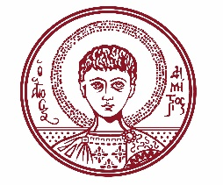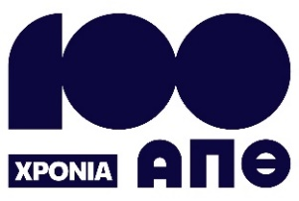

ARISTOTLE UNIVERSITY OF THESSALONIKI
PRESS OFFICE

ph. (+30)2310 997158 e-mail:press@auth.gr
Administration Building «Κ. Karatheodori» AUTH, P.C. 541 24, Thessaloniki
^{@Aristoteleio @authuniversity} ^{@Auth_University}

PRESS RELEASE

AUTH celebrates 100 years with research and innovation at the Thessaloniki International Fair (TIF).

Thessaloniki, 5/9/2025

Aristotle University of Thessaloniki (AUTH) actively participates in the 89th Thessaloniki International Fair (TIF), taking place from September 6 to 14, 2025. The university showcases its academic and research achievements through innovative exhibits, cutting-edge applications, research programs, and by organizing a series of parallel events.

AUTH’s presence at the Fair offers visitors a valuable opportunity to discover the latest developments in research and technology. Guests can explore educational programs and institutional structures, experience up-close a range of innovative applications, constructions, and digital platforms, and learn about products developed by spin-off companies. The pavilion also provides a space for visitors to engage directly with distinguished scientific and student teams, and to participate in original presentations and thought-provoking discussions.

The official opening of AUTH’s pavilion will take place on Sunday, September 7 at 11:00 a.m. in Pavilion 17 ("Akademia"), stand 34.

To mark its 100th anniversary, AUTH will also present a special commemorative exhibition space at Pavilion 17 ("Akademia"), stand 44.

Additionally, visitors will have the opportunity to attend events hosted in the designated area for parallel activities, also located in Pavilion 17.

A detailed catalog of AUTH’s exhibits and the full schedule of parallel events is attached.
___________________________________________________
We kindly request that this event be published, broadcast, and covered by the media.

