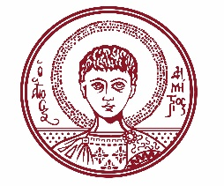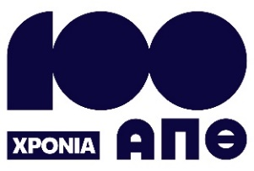

ARISTOTLE UNIVERSITY OF THESSALONIKI
PRESS OFFICE

ph. (+30)2310 997158 e-mail:press@auth.gr
Administration Building «Κ. Karatheodori» AUTH, P.C. 541 24, Thessaloniki
^{@Aristoteleio @authuniversity} ^{@Auth_University}

PRESS RELEASE

Open Event for Healthy Ageing

Thessaloniki, October 6, 2025

The Laboratory of Medical Physics and Digital Innovation at the Aristotle University is organizing an open event dedicated to active and healthy ageing. The event will take place on Saturday, October 11, 2025, from 10:00 to 15:00, at the Water Hall of the Thessaloniki City Hall.

The initiative is being held in collaboration with the Municipality of Thessaloniki, the Evosmos Health Center / 3rd Regional Health Authority (3YPE), and the Co-Housing Friends 60+ and 60− Association.

The main focus of the event is the presentation of the LLM Care Integrated Health Care System, a digital innovation developed at the Aristotle University to promote prevention and support active and healthy ageing. According to the organizers, LLM Care is a modern system for cognitive and physical empowerment, primarily designed for individuals belonging to vulnerable groups.

Visitors will have the opportunity to explore the world of exercise and empowerment through a virtual experience of the LLM Care system, participate in interactive games and activities, speak with the Aristotle University’s Scientific Team, take part in brief cognitive assessments, and learn about the Co-Housing Friends 60+ and 60− initiative.

This event goes beyond simple awareness-raising. It aims to foster a new culture of prevention and care, to affirm that healthy ageing is a right for all, and to highlight the Aristotle University’s role in merging scientific research with social contribution.

Admission is free and open to the public.
___________________________________________________
We kindly request that this event be published, broadcast, and covered by the media.

