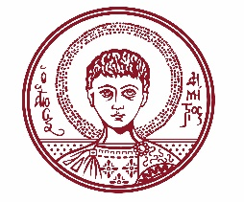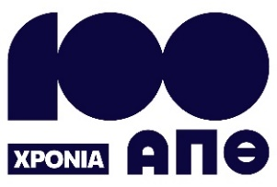

ARISTOTLE UNIVERSITY OF THESSALONIKI
PRESS OFFICE

ph. (+30)2310 997158 e-mail:press@auth.gr
Administration Building «Κ. Karatheodori» AUTH, P.C. 541 24, Thessaloniki
^{@Aristoteleio @authuniversity} ^{@Auth_University}

PRESS RELEASE

"50 Years of Memories from the School of Sciences at AUTH and Beyond": A Lecture by Christos Zerefos at an Event Organized by the Dean’s Office of the Faculty of Sciences at AUTH

Thessaloniki, 15/9/2025

Christos Zerefos, Secretary General of the Academy of Athens and National Representative for Climate Change, will deliver a lecture titled "50 Years of Memories from the Faculty of Sciences at AUTH and Beyond", at an event organized by the Dean’s Office of the Faculty of Sciences on Wednesday, September 17, 2025, at 18:30, in the Ceremony Hall of the Aristotle University of Thessaloniki (AUTH).

The event takes place as part of the celebration marking 100 years since the founding and operation of AUTH.

The Rector of AUTH, Professor Kyriakos Anastasiadis, and the Dean of the School of Sciences, Professor Nikolaos Kantiranis, will open the event with welcome addresses. Immediately following the greetings, the Dean’s Office of the Faculty of Sciences will present an award to Mr. Christos Zerefos.

Christos Zerefos serves as the Supervisor of the Research Center for Atmospheric Physics and Climatology of the Academy of Athens and as the National Representative for Climate Change. A distinguished academic and scientist in the fields of climatology and atmospheric physics, he has built an outstanding academic and research career.

He has taught at top universities in Greece and abroad, participated in numerous international research initiatives, and holds membership in many academies and scientific institutions. At the same time, he coordinates the Climate Change Impacts Study Committee of the Bank of Greece.

His work has received international recognition through major distinctions, including the Commander of the Order of Honour of the Hellenic Republic, the Order of Academic Palms from the French Government, and the Global Ozone Award from the United Nations Environment Programme. He has also received other significant awards for his contributions to the understanding of ozone mechanisms and climate change.

His contribution to the natural sciences is multifaceted: he has founded eight Greek and international scientific and educational centers, published over 250 scientific papers, and supervised a large number of doctoral and postgraduate theses.

More information about Mr. Christos Zerefos: www.christoszerefos.com

The event will be broadcast live at the following link: https://www.auth.gr/events/kentriki-ekdilosi-tis-scholis-thetikon/

___________________________________________________
We kindly request that this event be published, broadcast, and covered by the media.

